**Lesson13 Services**

**1-The Services is the layer that is responsible to get and set data from / to database**

**2-The Services is reusable code , so it can be used from multiple components (DRY) (don’t repeat yourself)**

**3-to create services on cmd write the following code**

**Ng g service MyServcies**

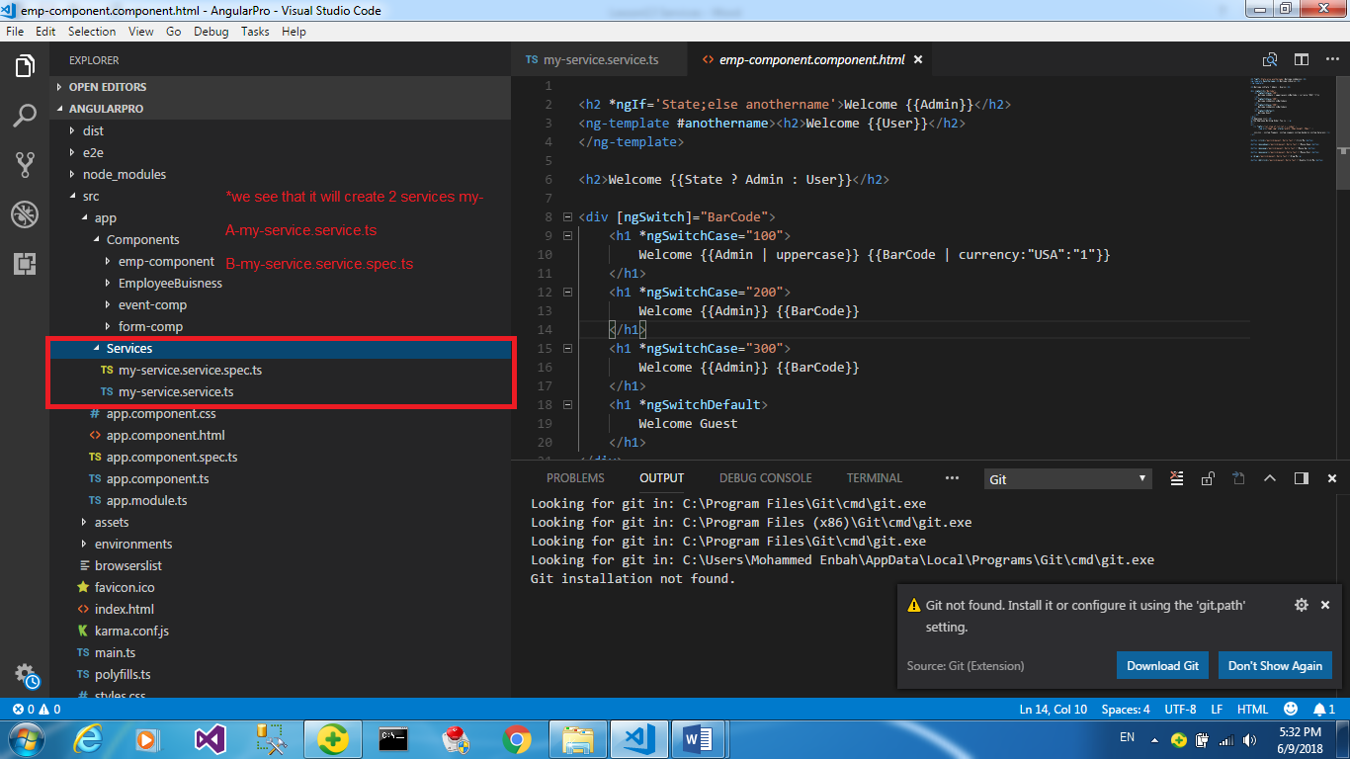

**4-we will create folder called BuisnessLogic which contain the business we need**

**import { generate } from "rxjs";**

**export {Admin,Employee}**

**interface IHomeContract{**

**FirstPart:string;**

**SecondPart:string;**

**HomePrice:number;**

**HomeTax:number;**

**CalcoulateHomePrice():number;**

**ShowHomeContractDetails():string;}**

**abstract class Employee implements IHomeContract {**

**FirstPart: string;**

**SecondPart: string;**

**HomePrice: number;**

**HomeTax:number = 0.05;**

**CalcoulateHomePrice(): number {**

**return this.HomePrice + (this.HomePrice*this.Tax);}**

**ShowHomeContractDetails(): string {**

**return `The Home Contract For First Part ${this.FirstPart}, And for Second Part ${this.SecondPart} <br/> And Home Price ${this.CalcoulateHomePrice().toString()}`;}**

**Fname:string;**

**Lname:string;**

**Gender:string;**

**Salary:number;**

**Tax:number = 0.02;**

**constructor(Fname:string,Lname:string,Gender:string,Salary:number,FirstPart?:string,SecondPart?:string,HomePrice?:number,HomeTax?:number){**

**this.Fname = Fname;**

**this.Lname = Lname;**

**this.Gender = Gender;**

**this.Salary = Salary;**

**this.FirstPart = FirstPart;**

**this.SecondPart = SecondPart;**

**this.HomePrice = HomePrice;**

**this.HomeTax = HomeTax;}**

**ShowEmployeeInfo():string{**

**return `The Employee Full Name ${this.Fname} ${this.Lname} ,And his Gender is ${this.Gender}`;}**

**abstract CalcoulateSalary():number;}**

**class Admin extends Employee {**

**Allowance:number;**

**constructor(Fname:string,Lname:string,Gender:string,Salary:number,Allownace:number,FirstPart?:string,SecondPart?:string,HomePrice?:number,HomeTax?:number){**

**super(Fname,Lname,Gender,Salary,FirstPart,SecondPart,HomePrice,HomeTax);**

**this.Allowance = Allownace;}**

**ShowEmployeeInfo():string{**

**return super.ShowEmployeeInfo()+` , and his salary ${this.CalcoulateSalary()}`;}**

**CalcoulateSalary(): number {**

**return this.Salary + this.Allowance;}}**

**//if you want only to retrieve data from database only , you can use this format with using the anonmous objects**

**class Person{**

**Id:number;**

**Fname:string;**

**Lname:string;**

**Gender:string;**

**Salary:number;**

**}**

**5-In the my-service.service.ts we can use the Class Admin from the Buinsess Logic**

import { Injectable } from '@angular/core';

import {Admin,Employee} from '../Buisness/Employee';

@Injectable({

providedIn: 'root'

})

export class EmpServiceService {

constructor() { }

ShowEmployee(): Admin[] {

return(

[

new Admin("Mohammed","Enbah","Male",500,40,"First Part Mohammed Enbah","Second Part ETC",40000,0.01),

new Admin("Ali","Osama","Male",300,40,"First Part Ali Osama","Second Part ETC",50000,0.01),

new Admin("Walled","Enbah","Male",600,40,"First Part Walled Enbah","Second Part ETC",60000,0.01)

]);

//you see that we use the anonymous objects to retrieve data from the database

ShowPersons():Person[]{

return([

{Id:1,Fname:"Mohammed",Lname:"Talal",Gender:"Male",Salary:400},

{Id:2,Fname:"Yousef",Lname:"Eman",Gender:"Male",Salary:500},

{Id:3,Fname:"Riyad",Lname:"Waleed",Gender:"Male",Salary:600},

]);}

}}

**6-in the app.module.ts , we link the service and add to the providers**

import { BrowserModule } from '@angular/platform-browser';

import { NgModule } from '@angular/core';

import { AppComponent } from './app.component';

//we see that the service added to the app.module.ts

import { EmpCompComponent } from './Components/emp-comp/emp-comp.component';

import {MyServicesService} from './Services/my-services.service';

@NgModule({

declarations: [

AppComponent,

EmpCompComponent

],

imports: [

BrowserModule

],

//we see that we add the service to the app.module.ts

providers: [MyServicesService],

bootstrap: [AppComponent]

})

export class AppModule { }

**7-In the emp-component.component.ts we import the service in the code behind**

import { Component, OnInit } from '@angular/core';

import {Admin,MyServicesService} from '../../Services/my-services.service';

@Component({

selector: 'app-emp-comp',

templateUrl: './emp-comp.component.html',

styleUrls: ['./emp-comp.component.css']})

export class EmpCompComponent implements OnInit {

lst:Admin[];

lstemp:Person[];

constructor(public empService:EmpServiceService) {

this.lst = empService.ShowEmployee();

this.lstemp = empService.ShowPersons();}

ngOnInit() {}}

**7-In the html page we apply the mehod**

<ul>

<li *ngFor="let item of lst" >

{{item.Fname}} {{item.Lname}}

{{item.Gender}} {{item.Salary}}

<br/>

{{item.ShowEmployeeInfo()}}

<br>

{{item.ShowHomeContractDetails()}}

</li>

</ul>

<ul>

<li *ngFor="let item of lstemp" >

{{item.Fname}} {{item.Lname}} {{item.Salary}} {{item.Gender}}

</li>

</ul>

**Notes:- If you want to send some parameter’s and apply the methods you entered , you have to use the new keyword and pass it as parameters ,**

**But if you want to retireve data only , you can use anonmous objects with condition that you must declare all component in each object you declared**